Draw a Activity diagram for Online Voting System for a software platform that allows groups to securely conduct votes and elections using CASE tools. The voters should be able to register via some proper authority. Construct a system in which the voters should see the list of candidates present in his constituency. A voter should be able to cast his vote to a candidate and that voter should cast only 1 vote at a time Draw an Activity diagram for Library Management System using CASE

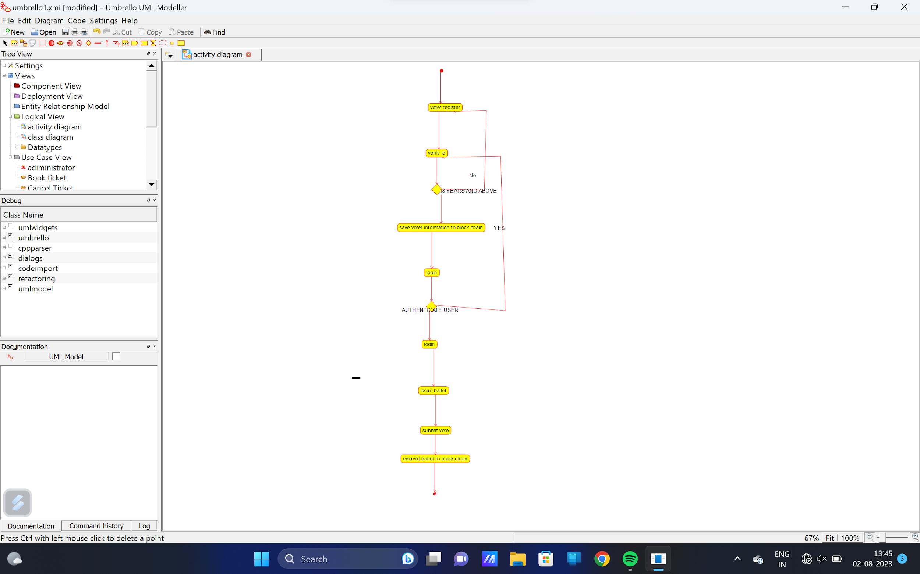

Draw a Activity diagram for Library Management System using CASE tools constructing User who registers himself as a new user initially who is regarded as staff or student. After getting the library card, a new book is requested by the user. After, requesting, the desired book issue the book to the user. Renew the book if the user needs the book again. Add the agent as Librarian and the user in the activity diagram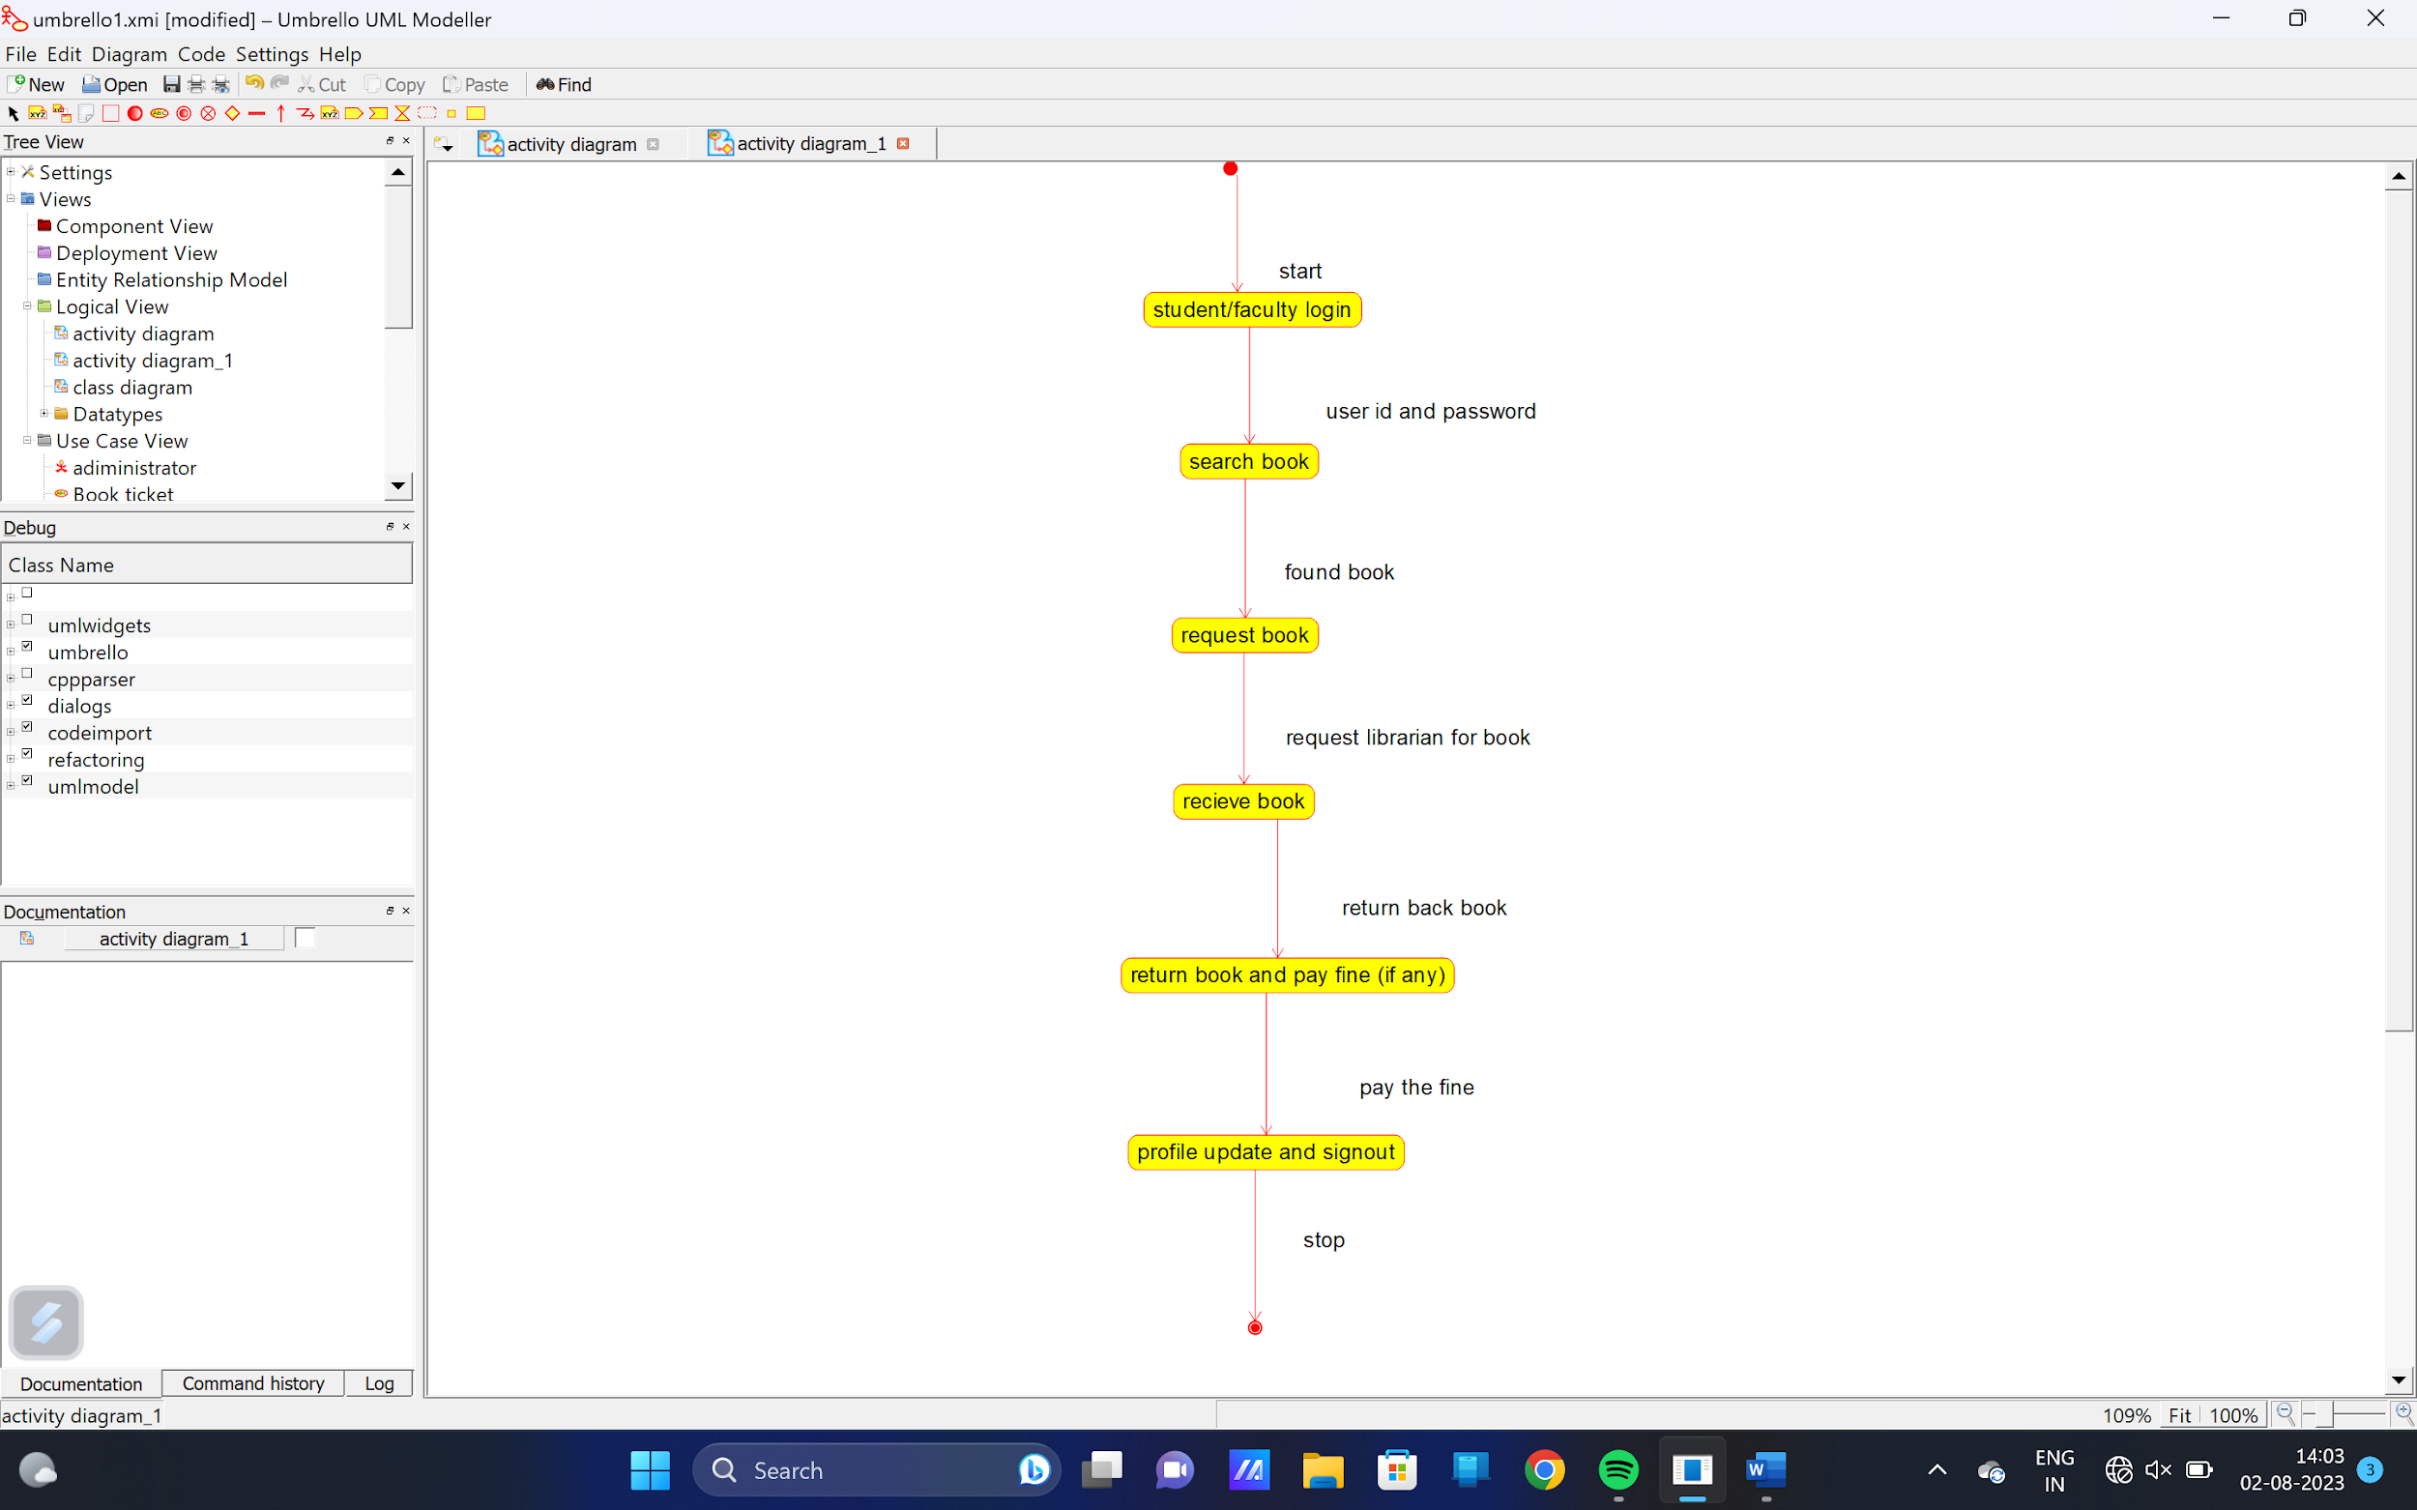Draw an Activity diagram for the Online Shopping system using CASE tools with standard steps like Login, Search, Browse, add to cart, edit cart, delete cart, confirm purchase, make payments, and receive items, rate website login and logout on the system.

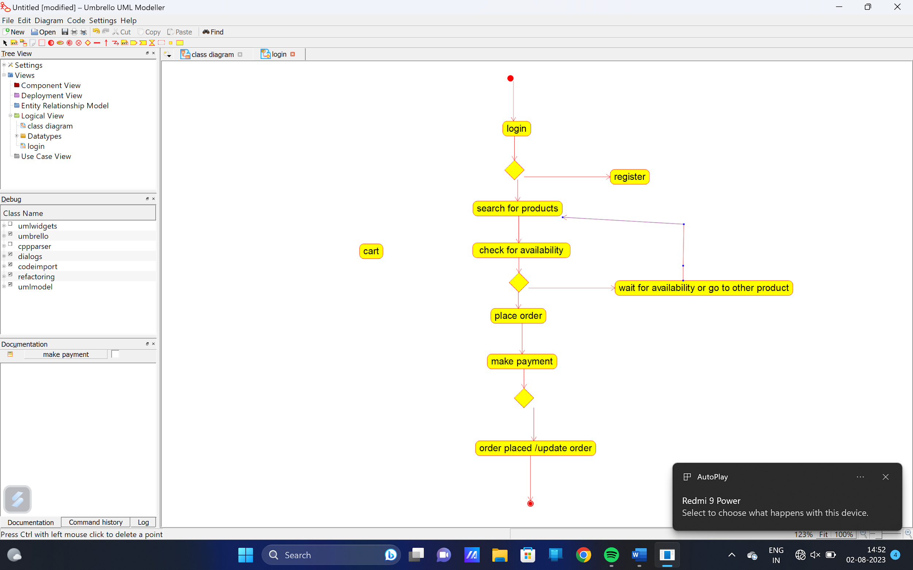Make an Online Airline Reservation System. The activities of the Online Airline Reservation system are listed below user, admin, LOGIN, MANAGE CLASSES, MANAGE WAITING LIST, MANAGE HOLDS, MANAGE DEADLINES, LOGOUT, using this has a step-by-step process draw a CLASS diagram Draw a Class diagram for Library Management System using CASE tools.

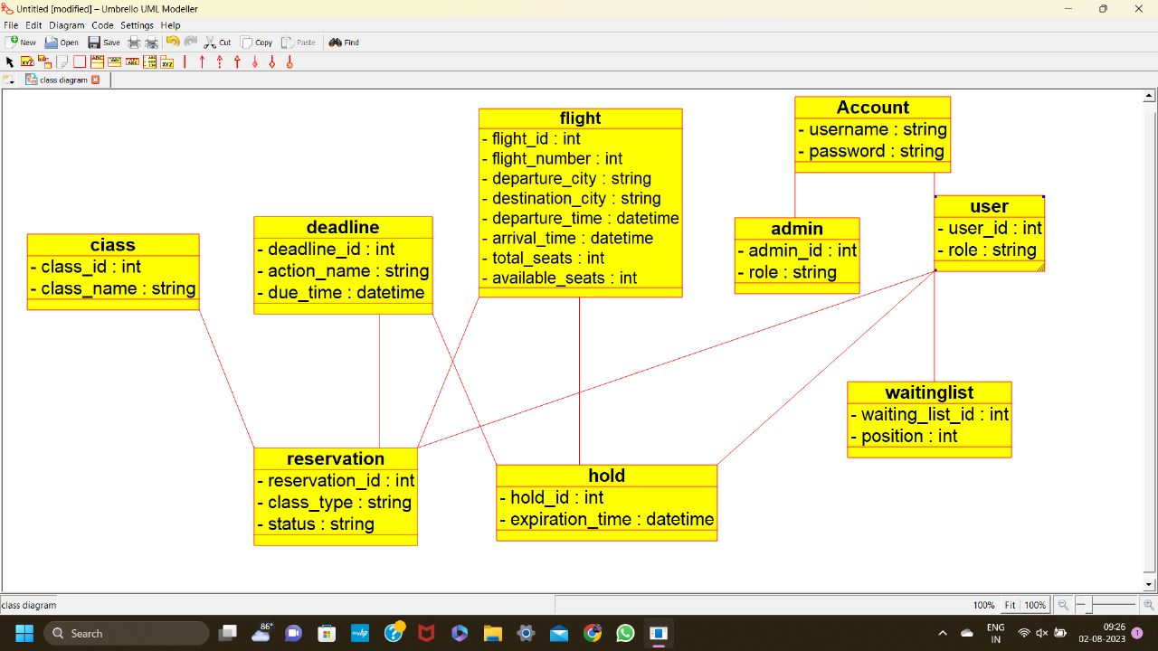Draw a Class diagram for Library Management System using CASE tools. Designing use case diagram for the library management system. User who registers himself as a new user initially is regarded as staff or student for the library system. Librarians have a key role in this system. Librarian adds the records in the library database about each student or user every time issuing the book or returning the book, or paying a fine. Design the class diagram for this

